How to import publications from BibTeX

- Make sure that the file is saved in BibTeX format by opening the .txt file in Notepad and saving it as a .bib file (change ‘Save as type’ from ‘.txt.’ to ‘All files’) 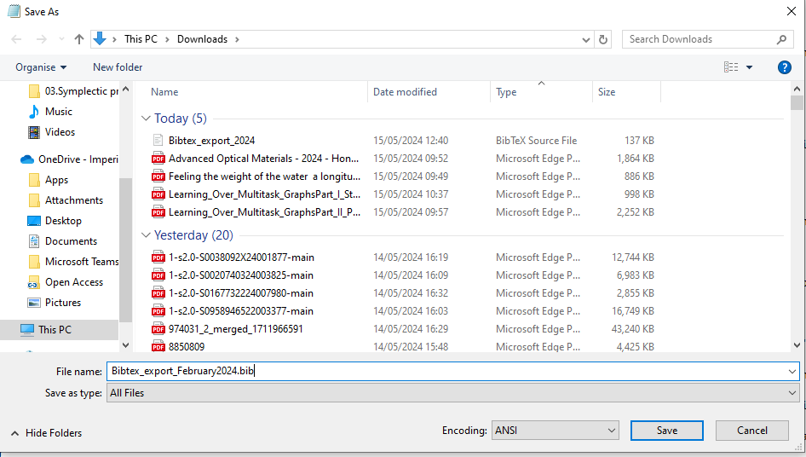

- If you are depositing on another author’s behalf, impersonate them on Symplectic

- Go to ‘My Profile’ – ‘Tools’ – ‘Import Publications’ 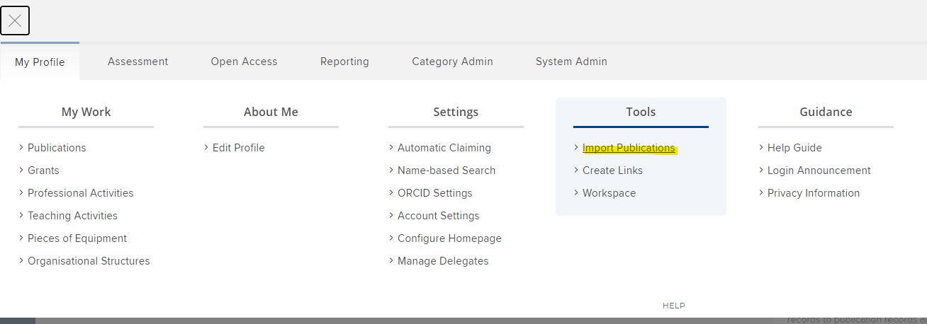

- Choose the file and click ‘Upload’ 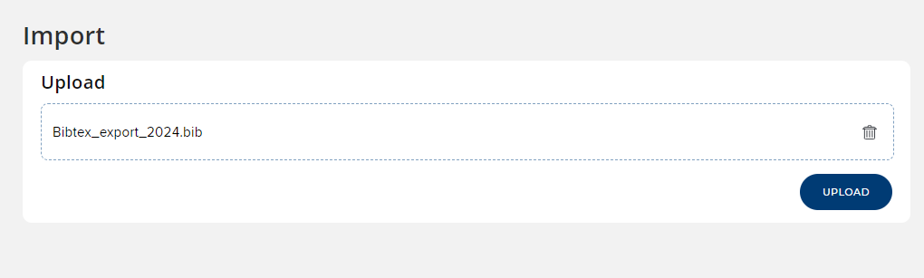

- For each item in the file, you can choose whether you want to just add a link, create a new publication, add a link to a manual record. You can also skip to ignore the record when there are multiple in the list but you only want to import some. Once you have chosen click ‘Import’.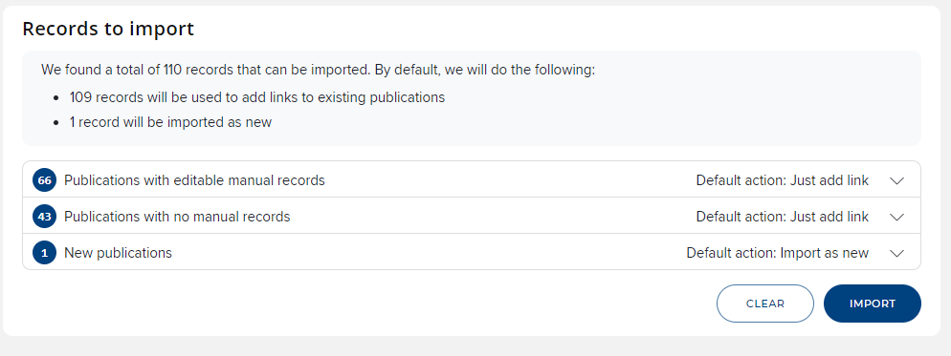

- The publications should now appear in your ‘My publications’ list on your homepage.


- From the ‘View all’ page, you can click on each record to deposit files and add/edit a manual record.

